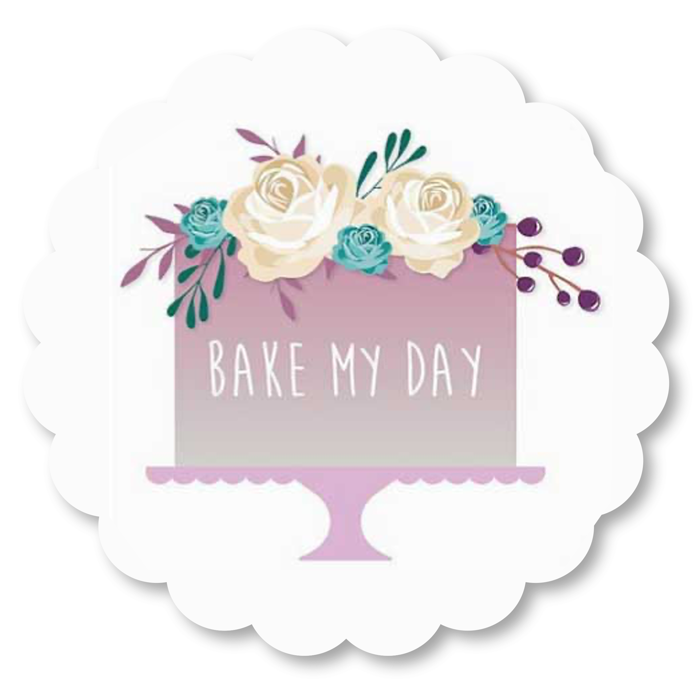

DEPOSIT:
There is a 30% deposit required to reserve your date. In the event of cancellation, your deposit is NON-
REFUNDABLE.

FINAL PAYMENT:
Total price is due 1 week prior to your Party / Wedding / Event date for larger cakes. All baked goods will not be made if final payment has not been received. When you place your order you will be advised as to when balance should be paid.

CAKE CHANGES:
Changes to your cake/cupcake order; size, description, flavour etc. will be accepted 2 weeks prior to the Party / Wedding / Event date. Charges may apply after the lock out date of two weeks, we cannot accept changes.

NON-EDIBLE DECORATIONS
All non-edible decorations will be highlighted to the Client during the order confirmation process, or on collection or delivery and it will be the responsibility of the Client to convey this to their guests and venue.
Bake My Day accepts no responsibility for any physical harm that may occur from the use of non-edible decorations requested by Clients.

CANCELLATIONS
Should you cancel your order before 7 days of the delivery/collection date, any monies already paid/still due from date of invoice, will be forfeited/due in full. However should you cancel after 7 days of the delivery/collection date and the cake/cupcakes has been started, you will be charged for the items made to date and any monies already paid/still due from date of invoice, will be forfeited/due in full. If the cake/cupcakes has been completed when you cancel your order, you will need to pay in full for the order placed and all deposits and monies already paid will be forfeited.
If you cancel after 7 days of the delivery/collection date or if the cake/cupcakes has been completed when you cancel you will not be entitled to take any items from the cancelled order that have been started or completed and you will still be charged in full for those items.

UNAVOIDABLE OCCURANCE:
In the case of an unavoidable occurrence, such as a car accident, poor road conditions, traffic during delivery etc. Bake My Day CANNOT be held liable for any delays or damages to the cake, however, we will try our very best to ensure that alternate arrangements are made to ensure that you are not completely without cake on the day of the event. We shall not be liable for any delay or inability to perform our obligations to you if such delay is due to any cause whatsoever beyond our reasonable control and you will not be entitled to a refund.
COLLECTION OF CAKES
Upon collection of your baked goods, any outstanding money will have to be paid. Bake My Day will not be liable should the customer believe there are any problems with the cake once it has left the premises. This includes design, colour or the bake of the baked goods. If we have to wait for any reason after the arranged pick up time, you will be billed at £20 per hour. Also be aware your cake/s is possibly not the only cake we have to output on this day, so we will not be late for any other scheduled deliveries that day. If we must leave without you collecting your baked goods, your baked goods can be collected at the next earliest opportunity and might mean that your baked goods may not be set up in time for your event at no fault to us, and without refund. The correct transportation guidelines will be given to you upon collection and should these not be followed and result in damage to the baked goods in any way whatsoever, Bake My Party will not be held liable for such damages.

STORAGE
All cakes/cupcakes should be stored at cool / air-conditioned temperature, out of direct sunlight on a flat surface and in the fridge ONLY when advised, unless specifically advised not to. No preservatives or additives are used in Bake My Day products therefore they should be treated as fresh food and consumed within 72 hours of the delivery/collection date.
Fruit cakes usually have a longer shelf life if they have had alcohol added to them in the baking process.
Should you wish to store your top layer fruit cake, the icing and marzipan should be stripped off the cake, the cake then wrapped in Clingfilm and frozen until required.
TERMS OF BUSINESS
Bake My Day shall not be liable for any consequential loss to the customer whether this arises from a breach of contract or any other way. Bake My Day total liability for any claim howsoever arising shall not exceed the price of the goods supplied by Bake My Day to the customer.
If you are unhappy with your order and/or purchase, immediately notify us (within 24 hours of pick-up) of your concern and return your goods (minimum 95% of purchased goods) to us within a maximum of 36 hours from pick-up. Should the fault lie with Bake My Day, Bake My Day will refund you in full. If possible, Bake My Day will try its utmost to replace said goods if the time frame permits.
Please note pictures are for general illustration only and the product may vary from that shown.

PRIVACY POLICY
We will use your contact details (your name, telephone and your e-mail and postal addresses) to provide any services requested by you and also to tell you about important changes to the site and its functionality. These details will only be used by us and will not be passed to any other organisations.
FRESH FLOWER USAGE
In the case of fresh flower usage the responsibility of the flowers safety, quality, freshness, colour and safe food practice will rest with the florist and NOT WITH Bake My Day.

FOOD ALLERGIES
All of Bake My Days cakes, fillings, and frostings may contain or come into contact with soy, wheat, dairy or nuts. You acknowledge that you are responsible for informing your guests of this allergy information.

